Arrow of Light Adventure: Building a Better World
- Explain the history of the United States flag. Show how to properly display the flag in public, and help lead a flag ceremony.
- Learn about and describe your rights and duties as a citizen, and explain what it means to be loyal to your country.
- Discuss in your Webelos den the term "rule of law," and talk about how it applies to you in your everyday life.
- Meet with a government leader, and learn about his or her role in your community. Discuss with the leader an important issue facing your community.
- Learn about your family's expenses, and help brainstorm ways to save money. Plan and manage a budget.
- Learn about energy use in your community and in other parts of our world.
- Identify one energy problem in your community, and find out what has caused it.
- With the assistance of your den leader or parent, participate in an event that would help lead others in recycling and conserving resources.
- Show that you are an active leader by planning an activity without your den leader's help.
- Do one of these:
  - Learn about Scouting in another part of the world. With the help of your parent or your den leader, pick one country where Scouting exists, and research its Scouting program.
  - Set up an exhibit at a pack meeting to share information about the World Friendship Fund.
  - Find a brother Scout unit in another country.
  - Under the supervision of your parent, guardian, or den leader, connect with a Scout in another country during an event such as Jamboree on the Air or Jamboree on the Internet or by other means.
Workbook for use with these requirements: PDF Format DOCX Format

Messengers of Peace
http://scoutermom.com/14582/messengers-of-peace/
The Messengers of Peace initiative is a program of the World Scout Committee. The Boy Scouts of America joined the Messengers of Peace initiative in 2012. This program encourages Scouts around the world to work for peace by being a positive force in their communities. All types of BSA units can participate in this program.
The program tracks how the efforts of Scouts around the world are making a difference for peace. You can even see a map with pins where Scouts are participating.
Participating is easy. When you submit a service project for Journey to Excellence, just select “Messengers of Peace” as your partner organization.
Scouts and Scouters who participate in a Messengers of Peace service project may wear a Messengers of Peace ring patch around the World Crest on their uniforms.

What type of service project qualifies as a Messengers of Peace project?
You don’t need to travel the world to be a Messenger of Peace. According to the BSA website:
A Messengers of Peace service project is defined as any project that touches on one of these dimensions of peace:
- The personal dimension: harmony, justice, and equality
- The community dimension: peace as opposed to hostility or violent conflict
- Relationships between humankind and its environment: security, social and economic welfare, and relationship with the environment
Many of the service projects your units are doing will qualify. See the Messengers of Peace Service Project Ideas page for lots of examples.

Ideas for Adventure Requirements:
http://boyscouttrail.com/webelos/arrow-of-light-building-better-world-adventure.php
- Basic U.S. Flag information is in the Webelos handbook. Details can be found at usflag.org
- Review the 100 civics questions that U.S. Immigration Services uses for their naturalization test.
- A comparison of the United States and other countries can be found on this interactive map
- Plan this meeting well ahead of time. Meeting at the community leader's work place would be a good den outing. Let the person know what issue you'd like to discuss beforehand.
- Print this budget template for each scout.
- Research your area's energy generation, use, and potential witheia.gov map and energy.gov.
- Common household energy problems can be explored here and energy saving ideas are here.
- Learn about different conservation event ideas at epa.gov.
- Printing this activity plan template for each scout will help them with their planning.
- Use Pen Pals to connect with foreign scout groups.
Den Meeting Ideas for Building a Better World Adventure:
- Use some of these flag ceremonies - Flag Opening ceremony,Flag Closing ceremony,Flag ceremonies,More ceremonies
- Scouts can use these Pledge Intros to lead short flag ceremonies.
- Sing Grand Old Flag song or America the Beautiful song
- Tell I Am Your Flag minute
- Present this Flag skit
- Expand your Flag knowledge at this BSA page or by purchasing theYour Flag book from your local Scout Shop. Then, check your knowledge with this online Flag test. Understand Unit Flag devices.
- Consider working towards the Messengers of Peace award.

Cub Scout Conservation Project Ideas
By Mary Strain
- http://www.ehow.com/info_8242231_cub-scout-conservation-project-ideas.html
Boy Scouts of America, including Cub Scouts, have a long-time history in conservation and environmental work. Conservation ethics and activities have been part of the organization since 1910. Projects that teach Cub Scouts about the value and importance of conservation are educational and offer good reason for the 7- to 10-year-old boys to do something outdoors in this day and age when Scout badges include computer and other indoor projects. They may also help Cub Scouts earn pins and belt loops, including the Wildlife Conservation belt loop.
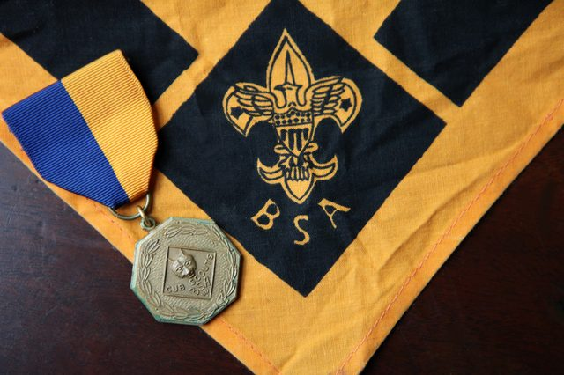(Jeanne Studio/Demand Media)

Planting Trees
One possible Cub Scout conservation project is a tree-planting project. This would be appropriate as part of an Arbor Day or Earth Day celebration. This hands-on project provides teaching opportunities for the leaders: Explain how trees help purify the air. Emphasize planting new trees helps restore forests and beautify areas where trees were lost to logging or construction. Possible sites for a tree-planting might include a park, library, school or retirement facility.
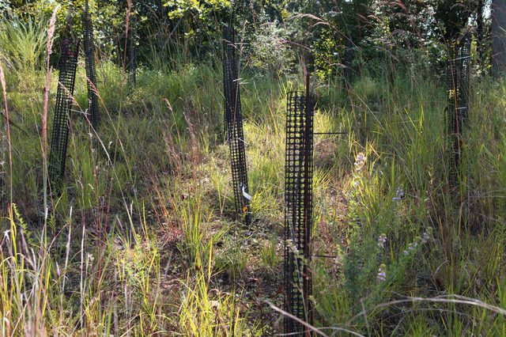Jeanne Studio/Demand Mdia

Recycling
Recycling is an important part of conversation. For a recycling project, plan a field trip the recycling center. Instruct the boys ahead of time to save recyclables for the field trip. If the center requires separating of glass, plastic and so forth, hand out instructions for the boys to take home so they remember how to sort. Talk to the boys about the length of time it takes waste to decompose and why this is a problem. After the field trip to the recycling center, swing by a landfill for a visual of the importance of recycling.
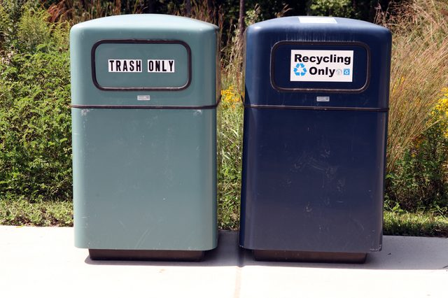Jeanne Studio/Demand Media

Walking and Biking
Taking the Scouts on a biking trip, whether as a day trip or as an overnight camping trip, is a fun way to demonstrate the importance of cutting back on carbon emissions by biking rather than driving, whenever possible. Alternatively, a Scout leader might explain the concept of a "carbon footprint" -- the size of one person's individual contribution to pollution -- by having the boys cut out paper footprints of varying sizes.
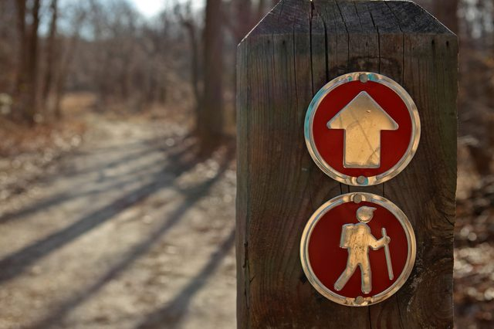Jeanne Studio/Demand Media

Adopt an Endangered Animal
The National Geographic Kids website suggests that children "adopt" an endangered animal as part of a conservation project. The Cub Scout den might choose to adopt an endangered animal at a local zoo or wildlife preserve. Wildlife sanctuaries, which rescue animals and return to the wild when possible, also welcome donations and sometimes provide adoption opportunities for animals that can't be released. To raise money for the adoption, plan a fundraising activity. Car washes are pretty dependable. Or try something that relates to wildlife, such as selling birdhouses or bat houses the boys make.

